ASSIGNMENT # 3 – TRAINING AN LLM

Part I:
- Think of a dataset (corpus) and a classification task. Ideally, both the corpus and the classification task can be used in your final paper. However, it’s OK if you do this for the assignment (you will still need a corpus). You can choose any task except sentiment classification.
Please see my GitHub for Assignment #3:
https://github.com/smurphyphd/text-analysis-public-university-llm/tree/main
The GitHub folder Assignment 3 contains the excel file I used to build my dataset and classify the data myself. This excel file, called “trainingdataset_ontario_budgets_v4_llm_sample”.xlsx, contains 202 observations. Each observation represents a paragraph from the introduction section of the operating budget of an Ontario university in advance of an academic year. My current sample contains operating budgets from Queen’s University and University of Toronto between 2017 and 2023. I selected this as an initial sample as Queen’s and UofT at times have had opposing financial results and leadership approaches to market conditions.
In 2019, the Ontario government imposed restrictions on domestic tuition fees, which some Ontario universities have attributed as the cause of poor financial performance post-2019. I am interested in how publicly funded universities in Canada talk about how dependent they are upon their provincial government. I want to see if there are differences in how these organizations perceive the external market and their place within it and if those differences are correlated with differences in financial results incurred t+1. I am choosing to analyze the introduction section of the operating budget of each Ontario university, created in advance of the academic school years pre and post 2019. These introduction sections, sometimes called “setting the context” or “the changing financial landscape”, outline the university’s perspective on its market conditions, the policy decisions of its provincial and national government, and how financially vulnerable or adaptable is their institution.
- Decide the number of categories that you will be predicting.
Academic Definition: Resource Dependence
Emerson (1962) argued that power resides implicitly in one’s resource dependence on the other in a relationship. The dependence of actor A upon actor B is (1) directly proportional to A's motivational investment in goals mediated by B, and (2) inversely proportional to the availability of those goals to A outside of the A-B relation. Goals = gratifications consciously sought as well as rewards unconsciously obtained through the relationship. Availability = alternative avenues of goal-achievement, most notably other social relations.
Emerson, R. 1962. “Power dependence relations.” American Sociological Review 27: 31-40.
I decided to code 2 categories (dependence = 1, non-dependence = 0). I am coding the university’s dependence on their provincial government for resources, as determined by their own perception or projection of that dependence in writing. I initially considered building 3 categories (low, medium and high dependence), but given the size of my sample for this assignment and this being my first time using LLMs to annotate and finetune, practicing with a binary category was a simpler initial approach. I may use a 3 category approach for my final assignment.
- Decide the number of observations you will code per category.
The following represents the breakdown of low vs high dependence observations I have in my sample after hand coding.
TOTALS
LOW |  | HIGH | TOTAL
82 |  | 120 | 202

- Create a draft codebook to guide coders who will (hypothetically) label your training set.
This codebook is related to the classifications I made in step 4.
Low Dependence:

Indicates a university’s low concern for the rewards/financial resources mediated by the provincial government (Emerson)

Quotes:
- the need to diversify revenue remains pressing
- promotes the vision of the university, transformative, the guiding policies
- differentiation envelope tied to performance in priority areas, this was a welcome change for the university and reflected the university's long-term advocacy for differentiation
- the federal budget included significant new investments in research, new investments in canada research chairs, chairs make an important contribution to the university's operating budget, have a significant impact on the university's ability to recruit and retain outstanding scholars

- the university faces increasing financial pressure as a result of constrained provincial tuition and enrolment frameworks and real value decreases in provincial operating grants, the university's commitment to being an internationally significant research university requires creative solutions to fund its mission and aspirations

AND/OR

Indicates a university has a large perception of the availability of rewards/financial resources outside of the traditional relationship with the provincial government (Emerson)

Quotes:
- flexibility, contingency fund
- funding from the federal government is not generally part of the university's operating budget, however, it interacts with the University's budget in three important areas: canada research chairs, funding for the indirect costs of research, graduate student support
- it is anticipated a greater portion of future funding will be directed towards achievement of accountability metrics, engaged in consultation with the province on the design of metrics and funding mechanisms that will be included in SMA3
- the final report of the alternative funding sources advisory group articulated several potential sources of revenue-generation that take advantage of some of the university's key strengths, underpinned by overarching principles that are committed to protecting the university's reputation, building a pipeline of new ideas, financial flexibility
- the university has seized another such opportunity with the adoption of the four corners strategy, leverage real estate assets, support the academic mission, simultaneously grow revenue from sources other than enrolment, sets an ambitious goal of generating $50 million in operating funding per year by 2033, development of new space, funding invested in research and teaching mission, several projects are now underway in various stages of planning, design and construction, this new revenue stream is not yet reflected in long-range budget assumptions

High Dependence

Indicates a university’s strong concern for the rewards/financial resources mediated by the provincial government (Emerson)

Quotes:
- almost 97% of operating grants
- found itself grappling, the effects not yet fully understood
- funding in the performance-based envelope will be at-risk unless the targets are continually met
- provincial grant revenue is financially limiting, any sustained growth above the mid-point does not result in additional provincial grant funding
- the provincial government announced the tuition framework, which continues to restrict flexibility for the university by freezing tuition fees

AND/OR

Indicates a university has a limited perception of the availability of rewards/financial resources outside of the traditional relationship with the provincial government (Emerson)

Quotes:
- limited flexibility, much of this revenue is directed and regulated
- measures and requirements were expected to impact university
- however the province will provide institutions with the ability to increase tuition fees for domestic out-of-province students
- all units planned their budgets and reductions, the funding that was cut was held in a deficit mitigation fund, the entire deficit mitigation fund allocated to FAS along with a portion of the transition fund (university fund)
- the ministry re-introduced the funding linked to SMA3 metrics but at lower rates than were originally contemplated, this now places 10% of funding at risk for 2023-2024 and 25% at-risk for 2024-2025, the budget does allow for some revenue reduction

This is the version of that codebook I put into Google Colab for the LLM annotation:
COLAB CODEBOOK

prompt = """
Please classify the following sentence as either:
- 1 = resource dependence language
- 0 = non-resource dependence language

Resource dependence language refers to situations where an organization is constrained by, dependent on, or limited by external actors (e.g., government policies, funding structures, regulations).

This includes:
- funding being at risk or uncertain
- restricted flexibility due to external rules
- dependence on provincial or external funding decisions
- externally imposed constraints on operations

Only assign 1 if the sentence clearly reflects external constraint or dependence.

Examples of 1 cases:

the ministry re-introduced the funding linked to SMA3 metrics at lower rates, placing a portion of funding at risk

the provincial government announced a tuition framework that restricts flexibility by freezing tuition fees

much of this revenue is directed and regulated by the provincial government

Examples of 0 cases:

the university is pursuing alternative sources of revenue and diversification strategies

the university launched a strategy to generate new revenue streams from real estate assets

faculty emphasized innovation, differentiation, and long-term growth

Return only one character: 0 or 1.
""".strip()

- Label a sample of your data (N=200); decide how you will sample the data and explain your decision. Have a LLM label the same sample (you can find the code here). Estimate inter-coder reliability and evaluate the results.
See above. Data was human coded as 82 low and 120 high = 202 total observations.
I made a copy of the Google Colab coded provided in class to use LLM as my annotator: https://colab.research.google.com/drive/1EZQ2k3D6pcOc5l1rMuQgaX5Sxy0Eap6B#scrollTo=lUx_swqGSMAu
The Zero-Shot, Memory and Memory + Feedback models all provided similar results (see excel file on Github, “llm_all_predictions”.xlsx). See screenshots results below from Google Colab:
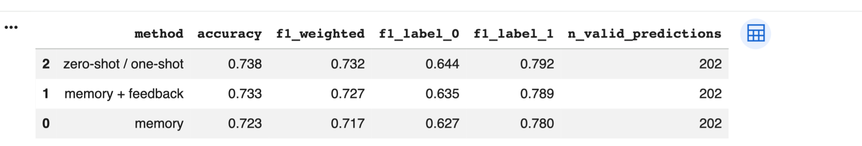
Zero-Shot
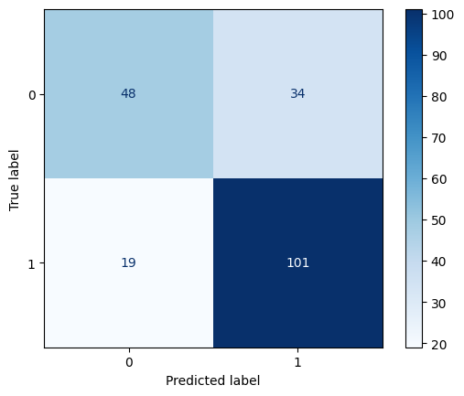
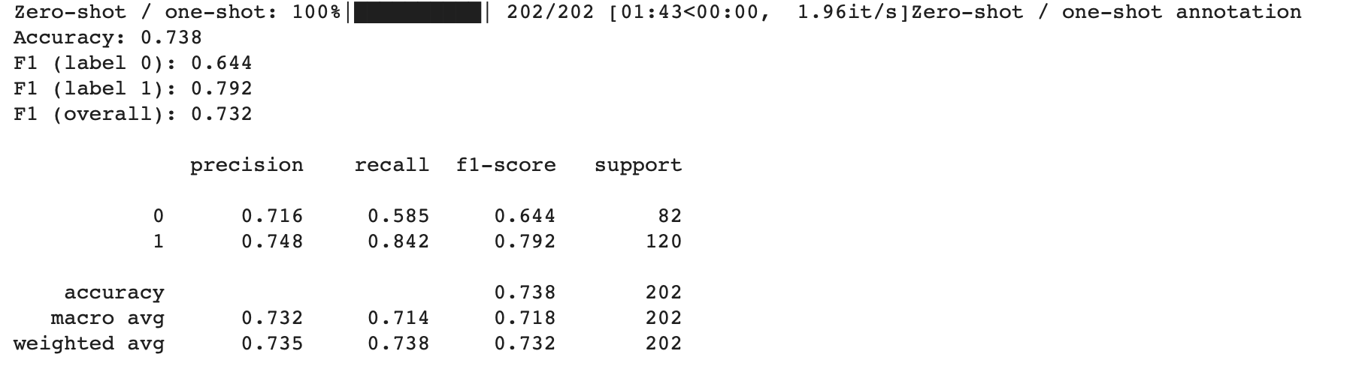

Memory
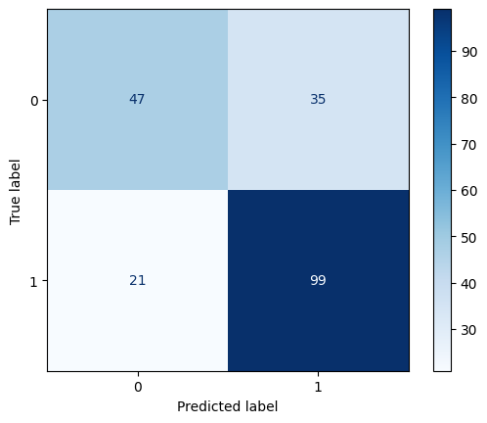
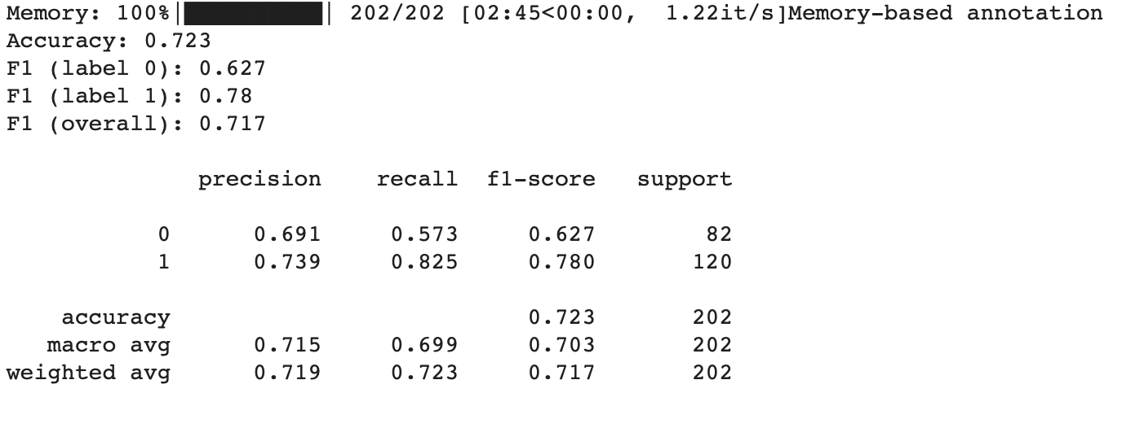
Memory + Feedback
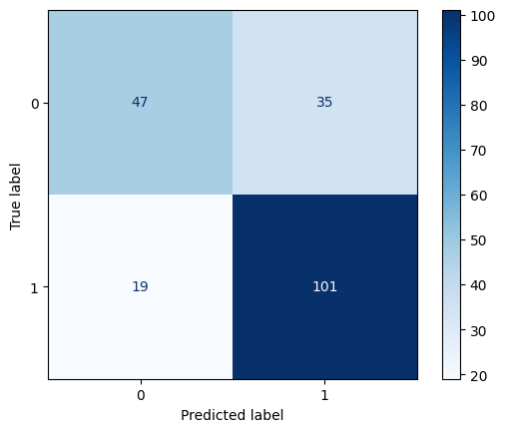
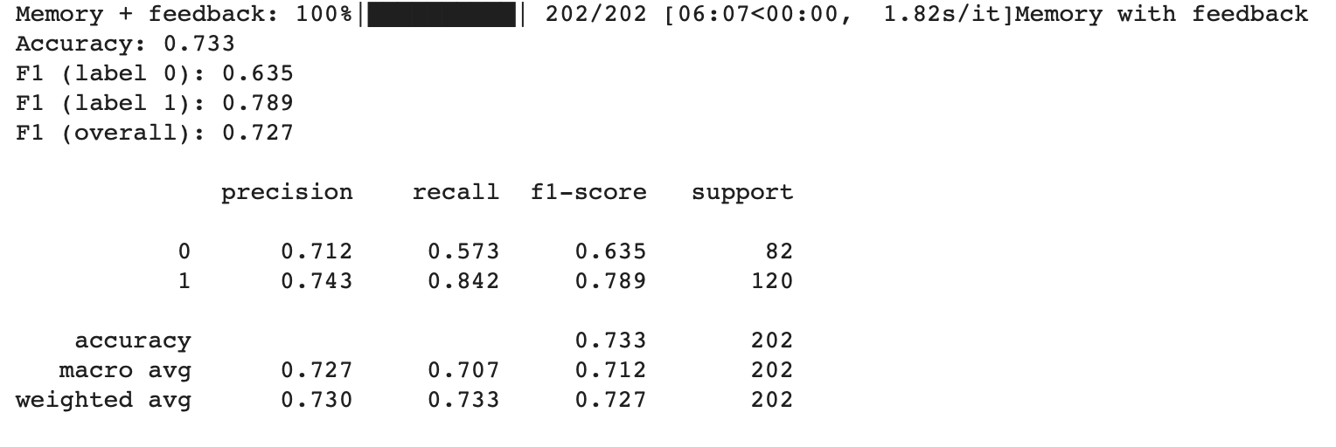
Intercoder Reliability
See RMarkdown in GitHub (Assigment 3 – ICR. RMarkdown).
I calculated intercoder reliability in R, comparing my human classification to the three different LLM models. Overall intercoder reliability appears moderate (Fleiss’ κ = 0.588). However, it is the pairwise agreement amongst LLM models that is high (κ = 0.72–0.82), whereas agreement between the human coding and each LLM is substantially lower (κ ≈ 0.41–0.44). This suggests that the LLMs are internally consistent but only partially capture the human judgment I did with my coding.
Evaluating the Results
The biggest discrepancy I noticed in the results was the difficulty in predicting 0s versus predicting 1s. While the accuracy rate on predicting “dependence” was around 84% (101/120), the accuracy rate on predicting “no dependence” averaged closer to 57% (47/82). In other words, the LLM models (relying upon my codebook) are generating significant false positives (35, Type I error) but relatively fewer false negatives (19, Type II error). The LLMS models are ultimately overpredicting dependence language in the universities when compared to my own human coding.

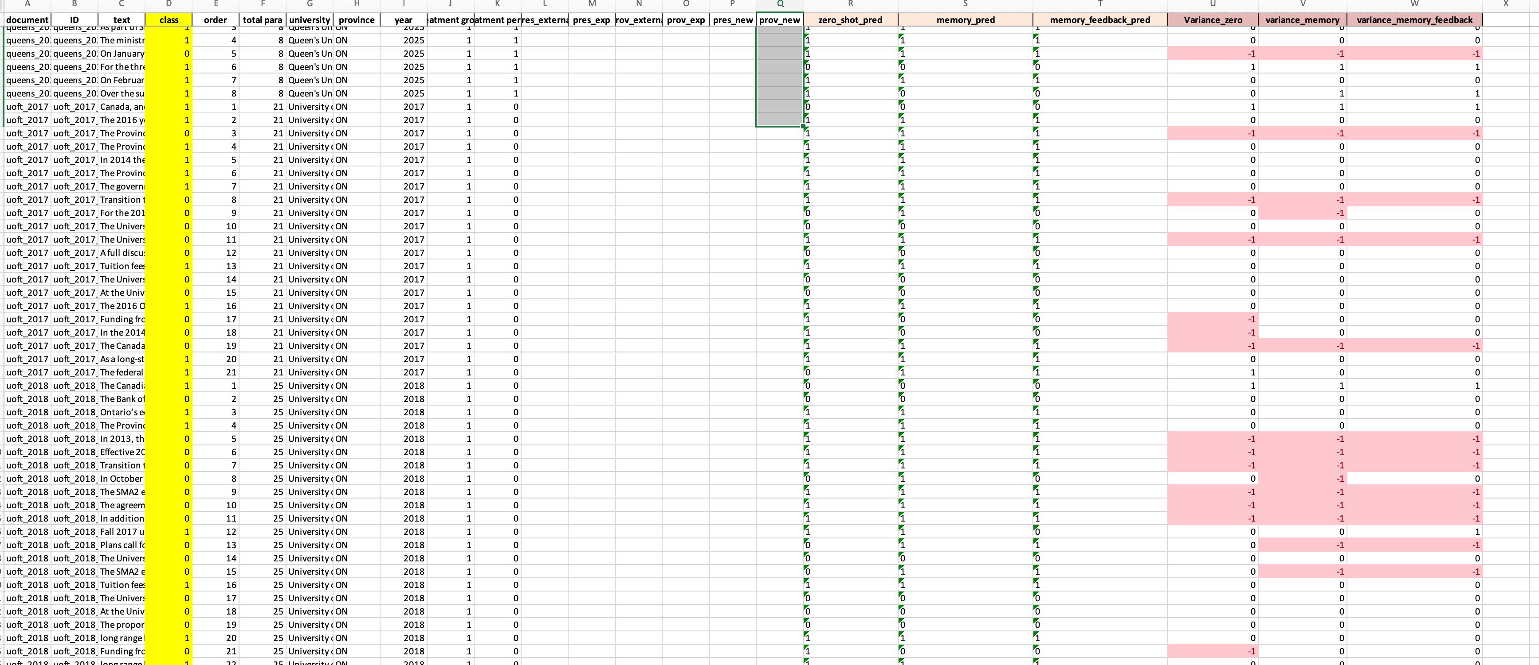
- How difficult or easy was the task? What problems did you run into? What would you change in your codebook to improve it? What other lessons did you learn from this exercise?
Relatively speaking, this was an easy task. The Google Colab code ran well once I adjusted the API key and inserted my datafile. I did have to write code at the end to export the LLM predictions a separate excel file, because I wanted to have this file on hand.
Looking at the discrepancies between the LLMs and the human coding (as seen in llm_all_predictions.xlsx – highlighted in red), many of them occurred with the University of Toronto sample. Some paragraphs that I coded as being low in dependence, since they reference the government (often the federal government as an alternative funding source) are labelled as high in dependence by the LLMs. I think I need to re-write my codebook to be clearer that dependence language does not necessarily always involve a discussion about the government. Low dependence has more to do about creativity and ingenuity in acquiring funds beyond typical grants or removing the domestic tuition freeze, which may involve some layer of government or be completely independent of government.
I also wonder if - because I gave criteria for 0s and for 1s in my codebook - that added complication for the LLMs. I should be clearer in specifying 1s only, and everything else will be coded as a 0. This also may speak to while using 3 categories (low, medium and high) may be better. I will go through each discrepancy and revise my codebook accordingly.

Part II:
- Once you have validated your training set and the labels produced by LLMs, expand the training set until you have (at least) 150 observations per category. You can use LLMs to label, but you will still need to manually validate the labels produced.
Extra Observations (150 per category)
I expanded my observations so there over 150 observations per category. This now saved as trainingdata_ontario_budgets_V5_llm_sample.xlsx in the GitHub. These observations were all hand-coded.
PART 2
LOW |  | HIGH | TOTAL
165 |  | 163 | 328
LLM Validation: Second Attempt
I also updated my codebook in Google Colab and had the LLMs try again. I removed reference to coding 0s and kept it only to coding 1s. I also refined how I define resource dependence for it to be more nuanced that is not strictly relate to referencing the government alone.
I used a new Google Colab: https://colab.research.google.com/drive/1zBvZ8adQOoXnlyx7_iXkkM-3exUiYizu#scrollTo=NLEOLjqIPqGz
prompt = """
Please classify the following sentence as either:
- 1 = resource dependence language
- 0 = non-resource dependence language

Resource dependence language refers to situations where a university feels constrained by, dependent on, the government. In particular, resource dependent universities feel limited by Ontario policies, such as the domestic tuition freeze, and talk as though there are not alternative ways for their operating revenues to grow or operating expenses to be covered. Less dependent universities look for alternative funding through their own means but also through looking to different layers of government or different programs outside of the tuition framework.

This includes:
- provincial funding being at risk or uncertain
- restricted flexibility due to domestic tuition freeze
- dependence on provincial government funding decisions
- externally imposed constraints on operations

Only assign 1 if the sentence clearly reflects external constraint or dependence.

Examples of 1 cases:

the ministry re-introduced the funding linked to SMA3 metrics at lower rates, placing a portion of funding at risk

the provincial government announced a tuition framework that restricts flexibility by freezing tuition fees

much of this revenue is directed and regulated by the provincial government

""".strip()

LLM Improvements: V5
Zero Shot
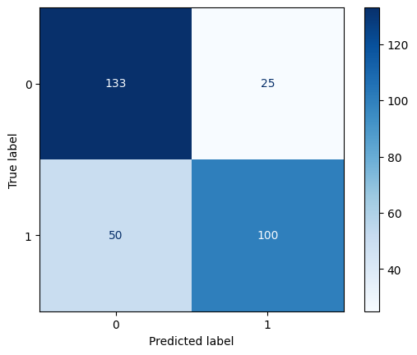
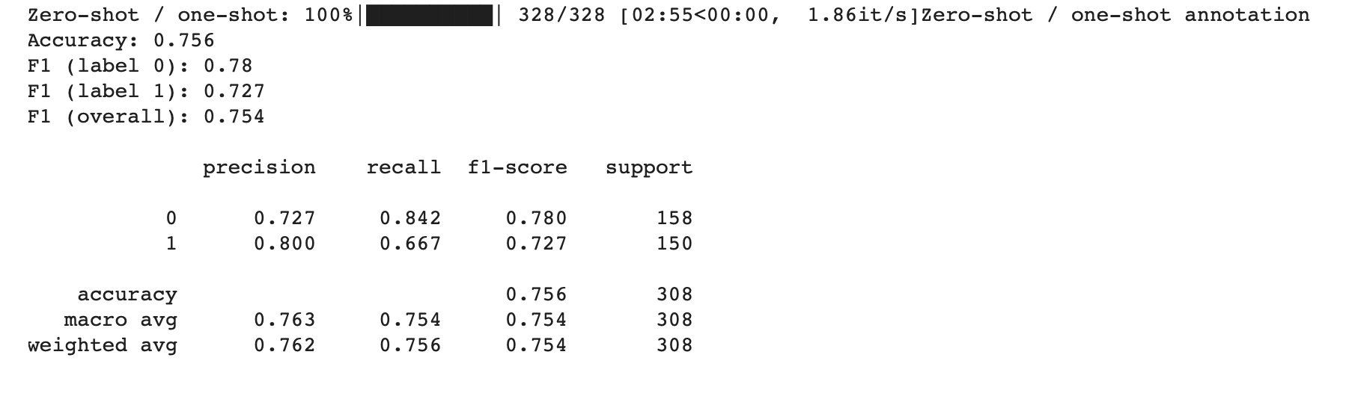
Memory
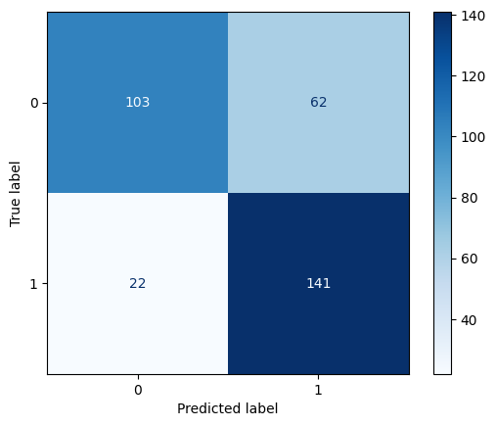
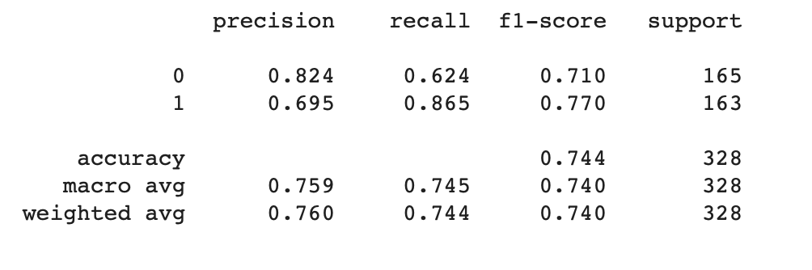
Memory Feedback

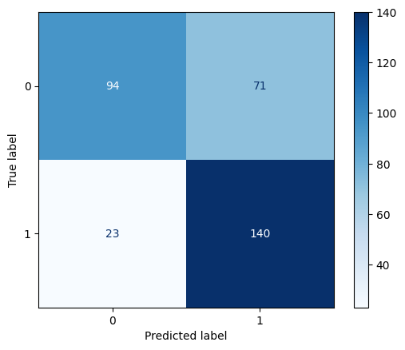

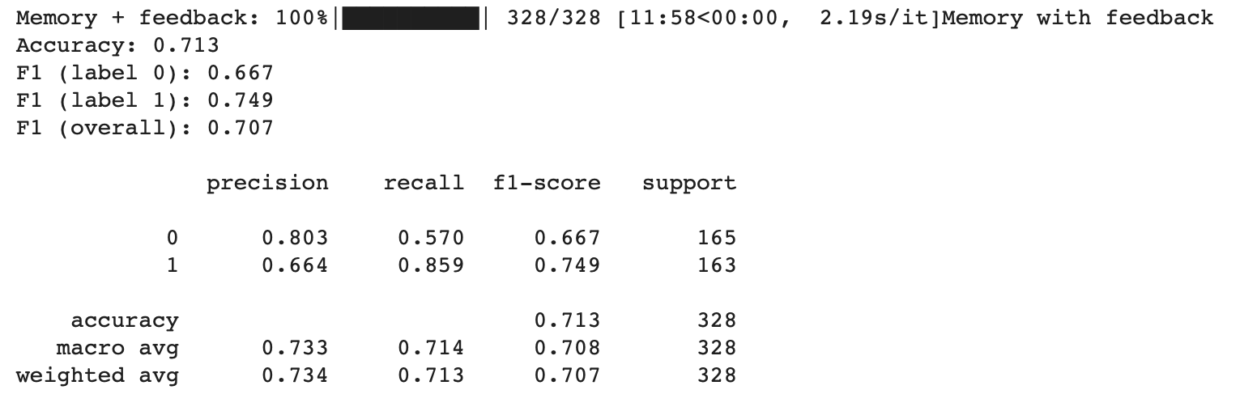

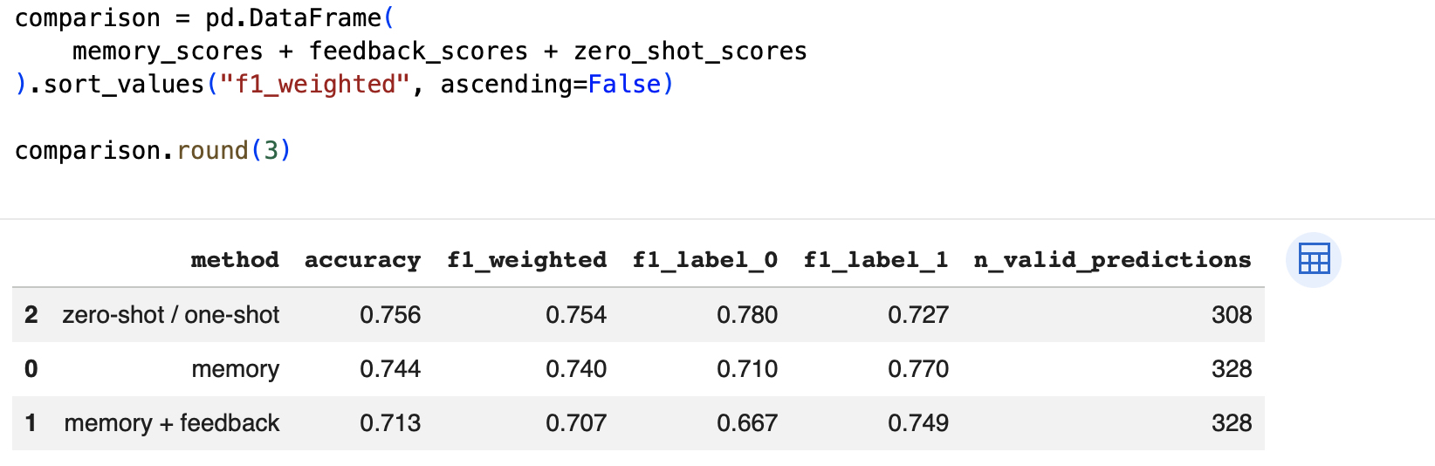

- Using your (validated) training set, fine-tune the encoder-only LLM of your choice.
I used a copy of the Fine Tuning Google Colab to fine-tune my model on the V5 sample:
https://colab.research.google.com/drive/1ne8x5RwFtfyBC0FiBR7FTyK9Cht0pf6b
Your output shows:
Accuracy ≈ 0.50
F1 for class 1 = 0.0
That means:
👉 Your model is basically not learning the positive class at all
Your model is:
- predicting mostly 0s
- failing to detect 1s
- producing false negatives problem (opposite of your earlier LLM issue)
This actually connects perfectly to your earlier analysis:
LLM → too many false positives
Transformer → too many false negatives
🔥 That’s a really strong methodological insight

1. Increase epochs
Right now:
epochs = 1
👉 Change to:
epochs = 3

2. Increase max_len
You are truncating 35% of texts:
117 of 328 texts truncated
👉 Try:
max_len = 200

What you’ve built:
- LLM prompt-based classifier → high recall, low precision
- Transformer fine-tuned model → low recall, maybe higher precision
👉 You are comparing two fundamentally different learning paradigms

- Report performance statistics for your fine-tuned model (e.g., accuracy, F1, recall, etc.), as well as the confusion matrix.
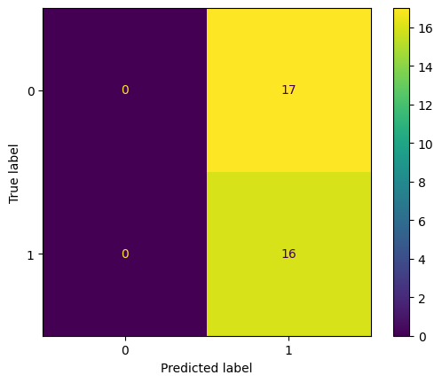
The performance of the fine-tuned RoBERTa model was evaluated using accuracy, precision, recall, F1 score, and a confusion matrix. The model achieved an accuracy of approximately 0.485 on the validation set.
The confusion matrix reveals that the model predicted all observations as class 1 (“dependence”), resulting in 16 true positives and 17 false positives, but zero true negatives and zero false negatives. As a result, recall for class 1 was perfect (1.00), but precision was substantially lower (0.485), yielding an F1 score of approximately 0.653 for the positive class.
In contrast, performance for class 0 was extremely poor, with precision, recall, and F1 all equal to zero, as the model failed to correctly classify any non-dependence observations.
These results indicate that the model is heavily biased toward predicting the positive class and lacks the ability to distinguish between the two categories. The confusion matrix highlights a systematic classification issue, where the model prioritizes recall at the expense of precision and overall balance.
Re-do
- Epochs = 3
- Max length = 288 tokens

After increasing the maximum sequence length to 288 (eliminating truncation) and training for three epochs, the model exhibited modest changes in behavior but did not achieve meaningful performance improvements. Cross-validation results showed a mean accuracy of approximately 0.465 and a mean weighted F1 score of 0.301, indicating performance close to random classification.
While the model no longer collapsed to predicting a single class across all folds, it remained highly unstable. In some folds, the model predicted almost exclusively class 0, whereas in others it predicted primarily class 1. This resulted in moderate F1 scores for one class paired with near-zero performance for the other, depending on the fold.
Averaged across folds, the model achieved similar F1 scores for both classes (F1₀ ≈ 0.335; F1₁ ≈ 0.316), but this reflects instability rather than balanced classification performance.
Overall, the results suggest that the model fails to learn a consistent and generalizable decision boundary, likely due to limited training data and weak signal differentiation between classes.
Method | Problem
LLM prompting | Too many false positives
Transformer (epoch=1) | Predicts only one class
Transformer (epoch=3) | Unstable / flips classes
👉 This is gold for your paper:
“Different methods fail differently”
--
Set k folds = 5
Learning rate = 1e-5
lr = 5e-6
After tuning model hyperparameters (learning rate = 1e-5, max sequence length = 288, and 5-fold cross-validation), performance improved modestly. The model achieved a mean accuracy of 0.51 and a mean weighted F1 score of 0.38 across folds.
However, performance remained highly unstable. While some folds showed relatively strong classification results (e.g., accuracy ≈ 0.74 and F1 ≈ 0.73), others exhibited near-random performance. This variability indicates that model performance is highly sensitive to the training-validation split.
Per-class results further show that the model performs better on the positive class (F1₁ ≈ 0.50) than on the negative class (F1₀ ≈ 0.29), suggesting a persistent bias toward identifying dependence.
Overall, while hyperparameter tuning improved performance relative to earlier specifications, the model still fails to learn a consistent and generalizable decision boundary.
--
Using stratified k folds….
stratified K-fold cross-validation, ensuring that each fold preserves the class distribution of the dataset. This reduces variability across folds and provides a more reliable estimate of model performance.
Your updated model (with StratifiedKFold + lr = 1e-5) now shows:
Mean Accuracy ≈ 0.573
Mean Weighted F1 ≈ 0.473
👉 Compared to before:
- Old: ~0.46 acc / ~0.30 F1
- Now: ~0.57 acc / ~0.47 F1
🚀 This is a substantial improvement
Mean F1_0 ≈ 0.42
Mean F1_1 ≈ 0.53
Mean F1_0 ≈ 0.42
Mean F1_1 ≈ 0.53
👉 This is huge:
- BOTH classes now have non-zero, meaningful performance
- No longer collapsing
- No longer flipping wildly

🔥 4. BUT still important: variability
Your folds still show variation:
- Some folds: ~0.50 accuracy
- Best folds: ~0.75 accuracy
👉 So:
The model is much more stable, but still not fully consistent
Model Performance
After implementing stratified 5-fold cross-validation and reducing the learning rate to 1e-5, model performance improved substantially. The fine-tuned RoBERTa model achieved a mean accuracy of 0.573 and a mean weighted F1 score of 0.473 across folds.
Unlike earlier specifications, the model no longer collapsed to predicting a single class and demonstrated meaningful performance for both categories (F1₀ ≈ 0.42; F1₁ ≈ 0.53). This indicates that the model is now learning a more balanced classification rule.
However, performance remains somewhat variable across folds, with accuracy ranging from approximately 0.50 to 0.75. This suggests that while the model has improved, its predictions are still sensitive to the specific training-validation split.
Overall, these results indicate that hyperparameter tuning and stratified cross-validation significantly enhance model performance, but the underlying classification task remains challenging due to limited data and weak signal differentiation.

What you’ve achieved (this is important)
You now have a clean methodological progression:
Stage | Result
Initial model | Collapse (predicts one class)
Tuned model | Unstable
Stratified + tuned | Balanced, improved, but imperfect
👉 This is exactly what professors want to see:
Iteration + learning + diagnosis

🔥 8. The key insight (this is your strongest contribution)
You can now say:
“Model performance depends heavily on validation design (stratification) and training stability (learning rate).”

⚠️ 9. What you should still be careful about
Even though this is better:
- Accuracy ~0.57 → still modest
- F1 ~0.47 → still not strong
👉 So frame it as:
- improvement ✔️
- but still limited ❗
Increased Sample to 400 observations total – add Windsor and Carleton
PART 2
LOW | HIGH | TOTAL
192 | 209 | 401
“Even after increasing the training sample to ~400 observations and tuning hyperparameters, model performance remained unstable across folds, with substantial variation in class-specific F1 scores. This suggests that the classification boundary between dependence and non-dependence is not strongly encoded in the textual features alone.”
- Use your trained model to predict labels on a target corpus.

- Describe the results obtained, and whether they match the expectations you had about the data.

I updated the coding for the model.

Trying testing the LLM as an annotator

Observations
PART 2 NEW
LOW | HIGH | TOTAL
323 | 78 | 401

Revised Codebook
prompt = """
Please classify the following sentence as either:
- 1 = resource dependence language
- 0 = non-resource dependence language

Resource dependence language refers to situations where a university feels constrained by or dependent on the government for revenue/funding. In particular, resource dependent universities feel limited by Ontario policies, such as the domestic tuition freeze, and talk as though there are not alternative ways for their operating revenues to grow or operating expenses to be covered. Less dependent universities look for alternative funding through their own means but also through looking to different layers of government or different programs outside of the tuition framework.

This includes:
- being in a vulnerable position
- limited financial flexibility
- restricted flexibility due to domestic tuition freeze
- limited revenue growth opportunities
- being disappointed with government decisions to place restrictions
- highlighting how insufficient funding is to cover costs

Only assign 1 if the sentence clearly reflects being "stuck", vulnerable or highly dependent on the government for resources. Simply stating or describing policy changes (such as the tuition freeze) is not a sign of resource dependence language.

Examples of 1 cases:

the ministry re-introduced the funding linked to SMA3 metrics at lower rates, placing a portion of funding at risk

the provincial government announced a tuition framework that restricts flexibility by freezing tuition fees

much of this revenue is directed and regulated by the provincial government, with limited flexibility for universities to increase revenue

UWindsor is in a vulnerable position—both literally and figuratively—

Examples of 0 cases:

The University faces increasing financial pressure as a
result of constrained provincial tuition and enrolment
frameworks and real value decreases in provincial
operating grants. The University’s commitment to being an
internationally significant research university requires
creative solutions to fund its mission and aspirations.

In 2019, the final report of the Alternative Funding Sources
Advisory Group4 articulated several potential sources of
revenue generation that take advantage of some of the
University’s key strengths

In 2019-20, the Ontario government required a 10 per cent
cut to domestic tuition fees and has subsequently frozen
fees at these lower levels out to at least 2026-27.

""".strip()

Zero Shot

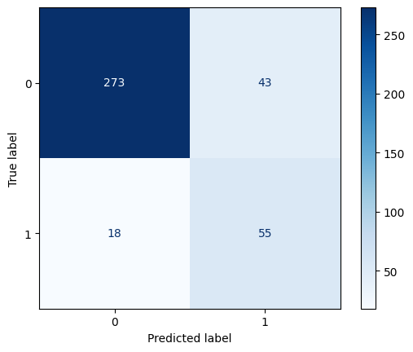
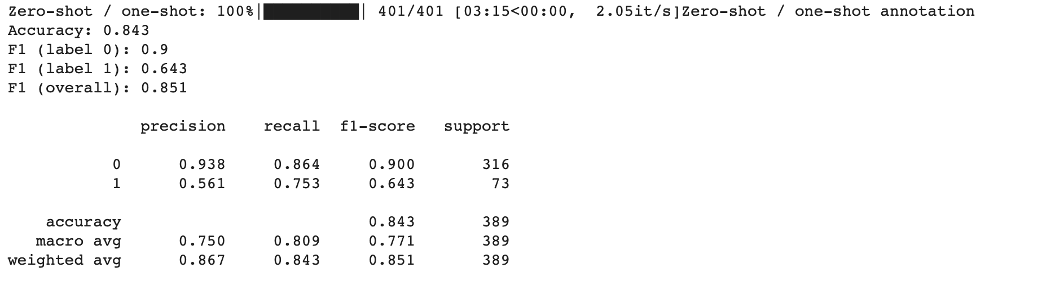

Memory
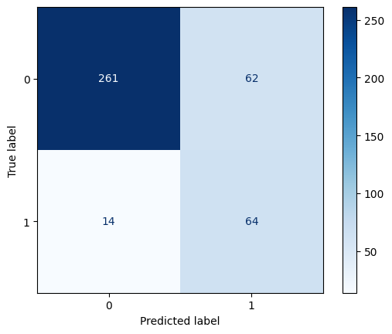
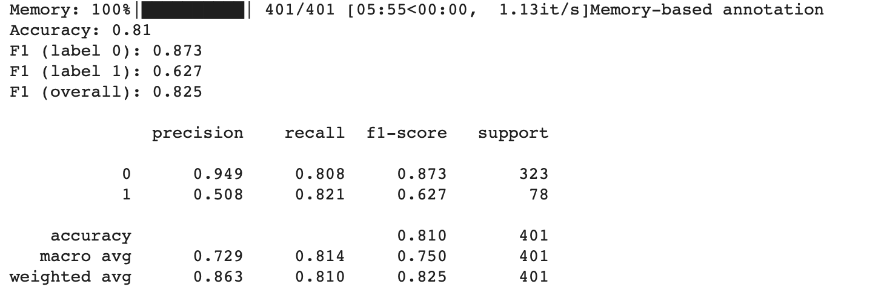

Memory Feedback
